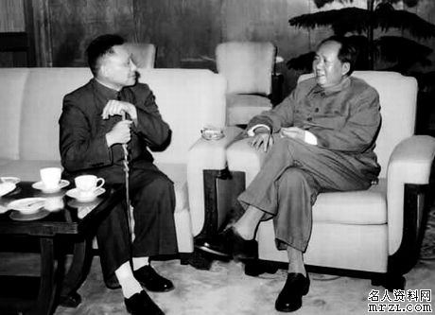
Best buds? Mao and Deng meet sometime in the mid-1960s.

Directions: read Woods, pp. 63-67 and answer the questions below.

- How was change accomplished in China before the 1900s? How does major political change happen today?1900’s was under dynastic rule and change occurred through the rise and fall of dynasties according to the mandate of heaven. At times when China was conquered they were forced to use the rules set by those powers. During imperialism it would have been dictated by what the imperial powers imposed. 20th century saw change come in the form revolutions and communist thought, and the end of the dynasties. Old traditions in politics have remained. Militaries have always played a key role. Modernization with opening up
- How did the USSR impact the early development of the People’s Republic of China? USSR in support of Mao, provided money and expertise, Used USSR 5 year plans as a model, allowed more personal freedoms especially with women, redistribution of land
- Why did Mao and other Communist leaders seek a break with the USSR? Mao wanted to break from USSR control and influence, 1958, instill a sense of nationalism in China, Mao not satisified with the continued inequalities in China
- What was the Great Leap Forward? What were the short-run and long-run consequences of the Great Leap Forward?A move toward a complete change in political and social thought. Focus to improve China’s economy, idea of a more utopian state, develop industry and agriculture, less unemployment, more work projects, party members in charge of the government instead of the beau racy , expected loyalty from lower government officials, more control of local issues to local governments moving away from more direct intervention by the national government. Short run: break from dynastic traditions, break from imperialist governments, higher employment, more local control, Long run: a split and vying for separate parties failed, Mao consolidated the CCP and placed the central government in control over entire population, moves towards modernization didn’t achieve the affect that was anticipated
- Write a brief biographical sketch of Liu Shaoqi and Deng Xioaping. Liu Shaoqi to help create more market style economyDeng Xiaoping head of the Central Military Commission a major force of Chinese government. Modernization of China’s economic policies, true to communism,incorporated the “Four Modernizations” plan which is still in effect today, Open Door trading policy, education reform, decentralized the government, higher education, a reversal of Cultural Revolution policies
- What was the Cultural Revolution and how did it impact political development in China? A more extreme reform for political, economic and social change. Meant to unify, settle problems with ethnic populations, massline, move towards collectivism (redistribution of land and money throughout the population), a more centrist population, to remove any vestiges (any evidence of) from old China, destroyed libraries and universities, removal of the intellectuals, basic reading and writing skills because higher learning would create inequalities in the population
- How did Deng Xioaping’s beliefs forge substantial shifts in China’s economic policies? Deng moved the country toward a more capitalistic approach to the economy, opened up more trade with the with the west, created SEZ’s to allow foreign markets to operate within China’s borders, encouraged and help with the reversal of Cultural Revolution policies.

