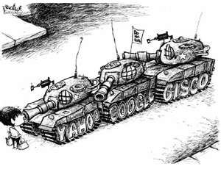

China: Modern China 02

Directions: read Woods, pp. 73-79 and answer the questions below.

- What is democratization and how have Chinese elections reflected democratization?
- Are Chinese elections democratic? Explain.
- Draw a political spectrum. How does China’s political spectrum compare and contrast with the spectrum that we have been using to analyze governments thus far?
- Check Transparency International’s most recent corruption index. How does China compare to Russia and the UK? What structure has been created in China to investigate allegations of corruption at the highest levels of government?
- What are the three most powerful polit6ical institutions in China? If I asked you to rank each in order of importance and power in China today, how would you rank them? Why?
- AP only (extra credit for everyone else). Read over pp. 75-77. How does Woods’ description of China’s political structure compare and contrast with that of the BBC?
- AP only (extra credit for everyone else). What were the “Four Modernizations” and how did these new policies reshape China’s political landscape?
- AP only (extra credit or everyone else). Have human rights improved in China during Hu Jintao’s tenure as China’s paramount leader? Discuss.

