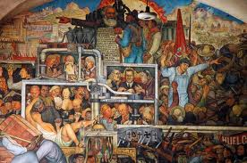

Mexico Question Set 02

Read Woods’ Mexico pp. 7-11 and answer the following questions

1. After gaining independence in 1821, explain what problems the young country of Mexico faced.

2. What was the “Portofiriato”? To what extent did Portofirio Diaz represent an authoritarian dictator?

3. To what extent was the Mexican Revolution of 1910 a success?

4. What were “caudillos,” and how did they represent a threat to Mexican national unity?

5. What accomplishments did the Constitution of 1917 achieve?

6. How did Plutarco Calles bring about stability in Mexico and establish the PRI at the same time? Make sure you briefly discuss what the PRI is!

7. Look up the PRI on Wikipedia and find out what their party platform planks are.

8. Discuss some of President Cardenas’ accomplishments. How would you rank them in order of importance?

9. What is the pendulum theory and how does it explain the differences between the Cardenas and Aleman presidencies?

10. Discuss Mexico’s two main political cleavages. AP Students: read the policy briefing on Mexico on the Moodle site.

